**Web Programming notes-15 Oct**

**Aria**- **Accessibility with Rich Internet Applications**

- A feature in html used for serving people with disabilities.

- no difference in HTML outputs.

**HTML syntax for Navigation Bar**

<nav>

<a></a>

</nav>

There are two ways we can make our applications accessible to differently-abled people.

● Whenever possible, use **semantic tags**.

● Use of **ARIA attributes**.

Refer: www.sitepoint.com/how-to-use-aria-effectively-with-html5/ for further details. Semantic tags are those tags that have a special meaning to the tag name.

We can also use <footer> tags.

Ex:

<footer>

</footer>

ARIA Attributes:

● role: For any purpose , we are not getting any semantic tag, then just apply the function role to regular html tags/alignments.

<div role=”notification”>Someone commented on your photo</div>

<nav role=”side-navbar”>

</nav>

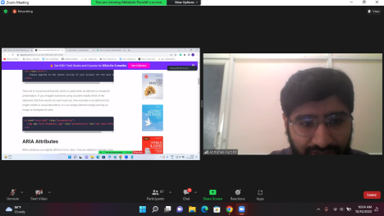

Whenever we are displaying radio buttons, we use:

**<input type=”radio”>**

**<input type=”checkbox”>.**

But there are cases where a developer can create their own custom radio buttons and checkboxes.

Ex: For creating a custom checkbox:

A custom checkbox can be created by using **<div></div>** tag.

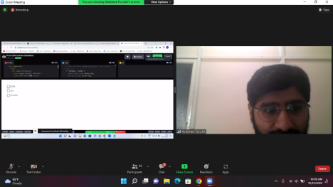

**Two types of aria- attributes:**

● **States** - something that will change (variable).

● **Property** - something that will not change (constant).

*Ex:****Checkboxes for Hobbies:***

● Property : hobby

● State : checked /unchecked.

aria-checked - gives **semantic meaning to user-defined functions.tags**.

Syntax for aria-checked

**<div aria-checked=”true”>**

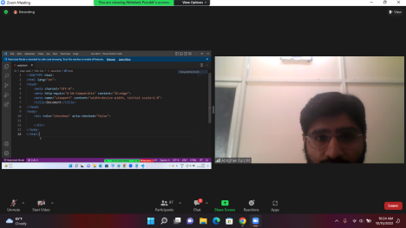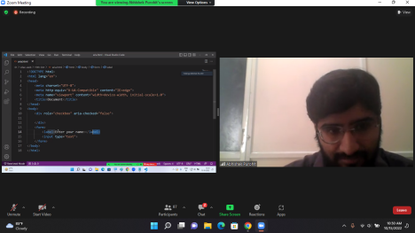**<input type=”text” placeholder=”Enter name” aria-labelledby=”name-input”>**

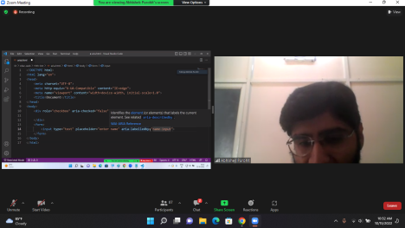

<input type=”text” placeholder=”Enter name” aria-labelledby=”name-reader.”> **aria-checked** is a **state** while **aria- labelledby** is a **property.**

Ex: **<div aria-labelledby=”hobbies-input>**

**<div role=”checkbox” aria-checked=”false”></div>**

**<div div role=”checkbox” aria-checked=”true”></div>**

**<div></div>**

**</div>**

**Client -Server Architecture.**

1. We cannot store the entire data into the client. So the server comes into the picture to store the data permanently.

In the sign up mechanism, the **role of the client** is to **display the form as well as send data to the server.**

The **role of the server** is to **read the data received from the client.**

There is some data exchange as well as communication between the client and server.

For effective communication between the client and server, they have to follow a set of rules. These rules are called **protocols** .

1. **HTTP Protocols**:

**HTTP => Hyper Text Transfer Protocol.**

**HTTPS=> Secure version of HTTP. It is recommended that while**

**hosting an application on any website or while banking online, we**

**must check the protocol. It is best if we use sites that follow https:// protocol.**

HTTP can be used for local applications.

***HTTP Request - Response mechanism:***

***Sending a request to server :***

Requirement of **IP address**- IP address is the **address used to recognize the target server on the internet.**

To simplify the process of storing the IP address on your machine, they brought in the concept of **domain name**.

Ex for domain names: www.facebook.com

We need the IP address/url of that server.

***Every request must have a type/method:***

Whenever we are sending request to the server, along with the url, a request method must be present (For what purpose we are sending the request to the server). **Request methods are mandatory.**

**Types of Request methods**:

**GET :**

Getting data from the server.

**POST:**

To send data on the server to create a new resource on the server. The post request will maintain the form data in the request body.

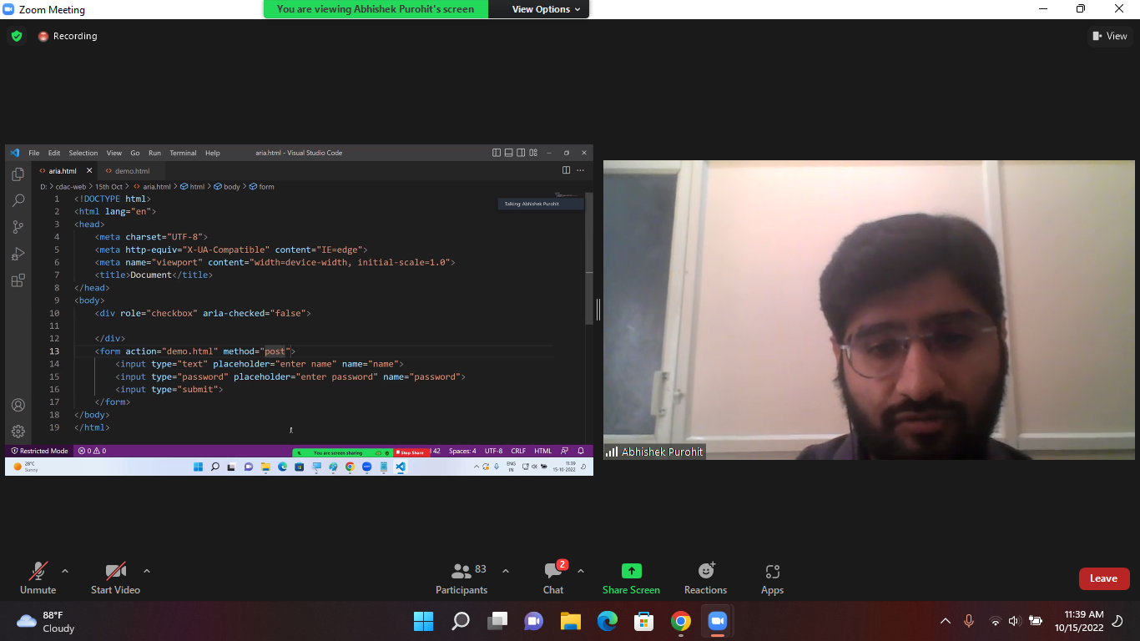

**PUT***:*

To send a request which will **update the entire data on the server.**

**Patch:**

Used to update **a small part of the data**.

**DELETE:**

To send a request which will **delete the resource from the server.**

NB: Whenever we send a request from the client application, we must specify the request method.If we haven’t specified any method, the GET request will be considered for action from this url..

**Refer on internet: idempotent request.**

**SERVER:**

● Infinitely listens to the requests.

● Accept the requests

● Process the requests

● Must give a response.

HTTP Response may have some data. **Along with data, HTTPResponse must have a status code.**

**The status code specifies the current state of the server/ what actually happened on the server side**. It is the way of sending the state of the server.

● Server has responded successfully.

● Server has an error.

● Request not found

● Server is busy.

● The Status code will always be of integer value.

● Any status code that has **4 as a prefix** , then it is the **fault of the client.** ● Any status code that has **2 as a prefix** , then it is a successful operation.

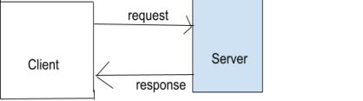

Ex: **404- Not Found**

**400- Bad request.**

**401- unauthorized.**

**200- OK**

**201- CREATED.**

**Refer: HTTP status codes.**

**○**